Rossmoyne Senior High School

Semester One Examination, 2014

Question/Answer Booklet

MATHEMATICS 3C
SOLUTIONS

Section Two:

Calculator-assumed

Student Number: In figures

In words

Your name

Time allowed for this section
Reading time before commencing work: ten minutes
Working time for this section: one hundred minutes

Materials required/recommended for this section

To be provided by the supervisor
This Question/Answer Booklet
Formula Sheet (retained from Section One)

To be provided by the candidate
Standard items: pens, pencils, pencil sharpener, eraser, correction fluid/tape, ruler, highlighters

Special items: drawing instruments, templates, notes on two unfolded sheets of A4 paper, and up to three calculators satisfying the conditions set by the Curriculum Council for this examination.

Important note to candidates

No other items may be used in this section of the examination. It is your responsibility to ensure that you do not have any unauthorised notes or other items of a non-personal nature in the examination room. If you have any unauthorised material with you, hand it to the supervisor before reading any further.

Structure of this paper

Section | Number of questions available | Number of questions to be answered | Working time (minutes) | Marks available | Percentage of exam
Section One:  Calculator-free | 7 | 7 | 50 | 50 | 33⅓
Section Two:  Calculator-assumed | 12 | 12 | 100 | 100 | 66⅔
 |  |  | Total | 150 | 100

Instructions to candidates

- The rules for the conduct of Western Australian external examinations are detailed in the Year 12 Information Handbook 2013. Sitting this examination implies that you agree to abide by these rules.

- Write your answers in the spaces provided in this Question/Answer Booklet. Spare pages are included at the end of this booklet. They can be used for planning your responses and/or as additional space if required to continue an answer.
- Planning: If you use the spare pages for planning, indicate this clearly at the top of the page.
- Continuing an answer: If you need to use the space to continue an answer, indicate in the original answer space where the answer is continued, i.e. give the page number. Fill in the number of the question(s) that you are continuing to answer at the top of the page.

- Show all your working clearly. Your working should be in sufficient detail to allow your answers to be checked readily and for marks to be awarded for reasoning. Incorrect answers given without supporting reasoning cannot be allocated any marks. For any question or part question worth more than two marks, valid working or justification is required to receive full marks. If you repeat an answer to any question, ensure that you cancel the answer you do not wish to have marked.

- It is recommended that you do not use pencil, except in diagrams.

Section Two: Calculator-assumed (100 Marks)
This section has twelve (12) questions. Answer all questions. Write your answers in the spaces provided.

Working time for this section is 100 minutes.

Question 8 (7 marks)
The height, metres, of a projectile above level ground is given by 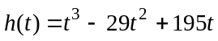, where is the elapsed time in seconds, 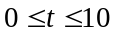.

(a) Determine the instantaneous rate of change of height of the projectile when 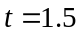
(2 marks)
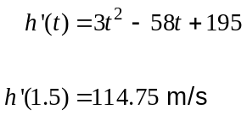

(b) Calculate the average rate of change of height of the projectile between and 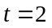.
(2 marks)
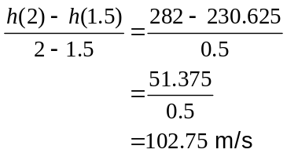

(c) Determine the height of the projectile at the instant that its height is decreasing at 69 metres per second. (3 marks)

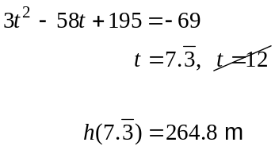

Question 9 (11 marks)
The mass of a drug remaining in the bloodstream of a patient is changing according to the rule 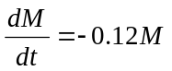, where 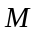 is the mass of drug remaining hours after the initial dose of 60 milligrams was administered.

(a) Describe the type of relationship between and . (1 mark)

Exponential decay

(b) Write down an equation for in terms of . (1 mark)

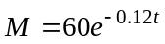

(c) Determine the mass of drug remaining in the bloodstream after one day. (1 mark)

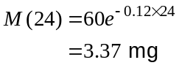

(d) Sketch the graph of against on the axes below. (3 marks)

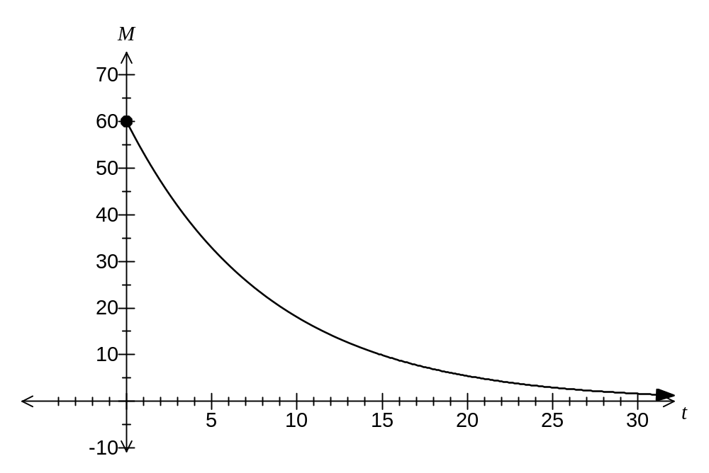

(e) Determine, to the nearest hour, the time taken for less than one percent of the initial dose to remain in the bloodstream of the patient. (2 marks)
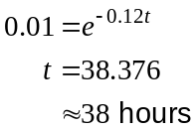

(f) At what rate is the mass of the drug in the bloodstream changing after 12 hours?
Give your answer to three significant figures and show the units of change. (3 marks)

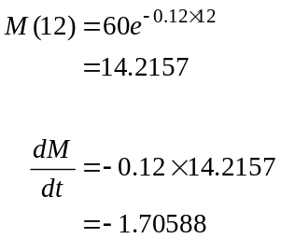

Hence decreasing at 1.71 mg per hour.

Question 10 (10 marks)
A transport company uses the same type of tyre for all 35 of its trailers. The number of kilometres that a new tyre lasts is normally distributed with a mean of 85 000 km and a standard deviation of 9 500 km.

(a) What percentage of all tyres bought will last more than 100 000 km? (2 marks)
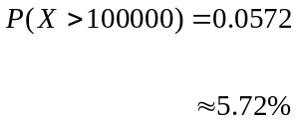

(b) Two tyres are chosen at random. What is the probability that neither tyre will last for more than 100 000 km? (2 marks)
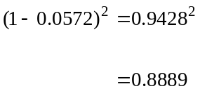

(c) Determine the distance that will be exceeded by 99% of all tyres. (2 marks)

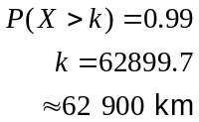

(d) Given that a tyre has already travelled 90 000 km, what is the probability that it will not last another 5 000 km? (2 marks)
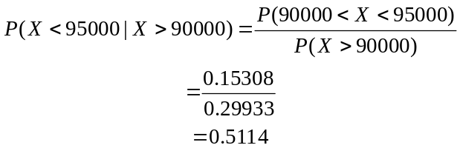

(e) A trailer is fitted with 12 randomly chosen new tyres. Calculate the probability that at least two of these tyres will last more than 100 000 km. (2 marks)
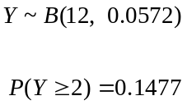

Question 11 (6 marks)
A farmer is growing watermelons and on a certain day it is estimated that, if harvested, the total weight of the watermelon crop would be 270 kg. At the same time, the price of watermelon was 88 cents per kg at the local market. For every day that the harvest is delayed, the total weight of the crop is expected to increase by 9 kg, whilst the price is expected to drop by 2 cents per kg.

Let be the number of days the farmer delays harvesting the watermelon crop.

(a) Show that the total value, in dollars, of the watermelon crop is given by 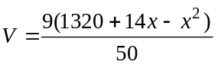. (3 marks)
Total Weight: 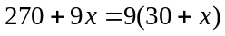

Price: 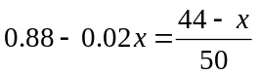

Hence 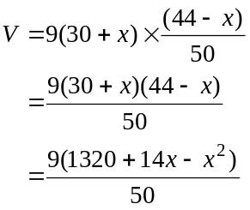

(b) Use calculus methods to determine the optimum number of days the harvest should be delayed to achieve the largest value for the farmer, and state this value. (3 marks)

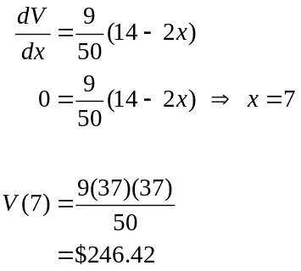

Question 12 (9 marks)
For two events, and , 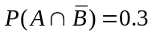, 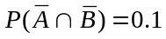 and 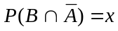.

(a) Determine an expression for 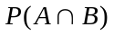 in terms of . (2 marks)

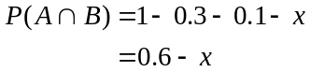

(b) State the maximum possible value of 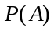. (1 mark)
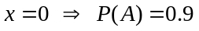

(c) Determine the value of under each of the following conditions.

(i) and are mutually exclusive. (1 mark)

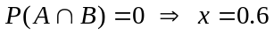

(ii) 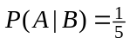. (2 marks)
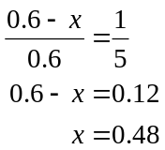

(iii) is independent of . (3 marks)

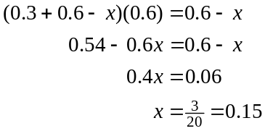

Question 13 (8 marks)
The clinical records of a large eye hospital indicate that

- 58% of patients are blue eyed (set )
- 42.9% of patients belong to the blood group O (set 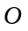)
- 31.9% of patients are blue eyed and do not belong to blood group O

(a) Use this information to complete the probabilities 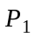 to 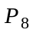 in the tree diagram below.
(4 marks)

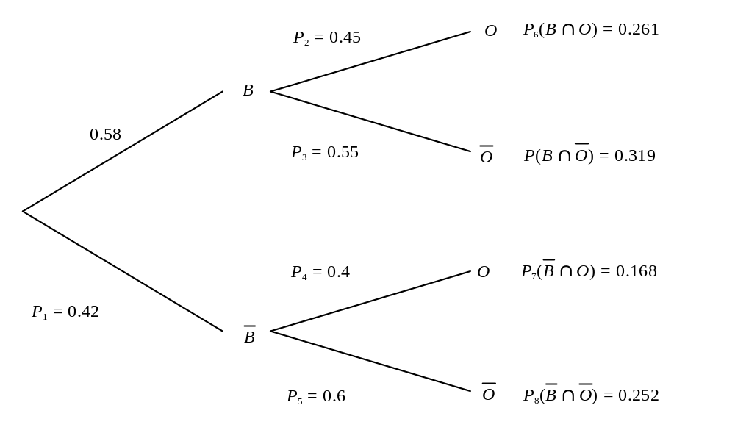

(b) What is the probability that a randomly selected patient will

(i) belong to blood group O and have blue eyes? (1 mark)
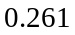

(ii) have blue eyes or belong to blood group O? (1 mark)

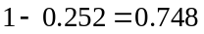

(iii) not have blue eyes, given they do not belong to blood group O? (2 marks)
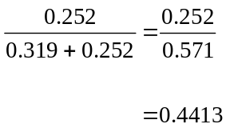

Question 14 (9 marks)
A new teaching method to improve arithmetic skills is being investigated by a school. A group of 50 students are randomly chosen to take part in a ten week trial of the new method.

There is a 60% chance that any one of these students will show an improvement in arithmetic skills after ten weeks, if they do not take part in the trial.

Let 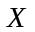 denote the number of students out of 50 who will show an improvement in arithmetic skills after ten weeks, if they do not take part in the trial.

(a) Is the random variable discrete or continuous? Justify your answer. (2 marks)
Discrete.

can only be integer values between 0 and 80.

(b) State the probability distribution of . (2 marks)
follows a binomial distribution with parameters 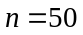 and 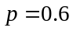.

(c) Calculate the mean and standard deviation of . (2 marks)
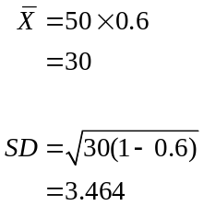

(d) What is the probability that at least half of the students will show an improvement in arithmetic skills after ten weeks, if they do not take part in the trial? (2 marks)
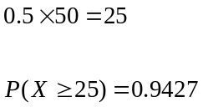

(e) What is the most likely number of students in a group of 50 to show an improvement in arithmetic skills after ten weeks, if they do not take part in the trial? (1 mark)

Most likely number is the same as the mean - 30 students.

Question 15 (7 marks)
The graphs of 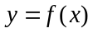 and 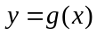 are shown below over their respective domains.
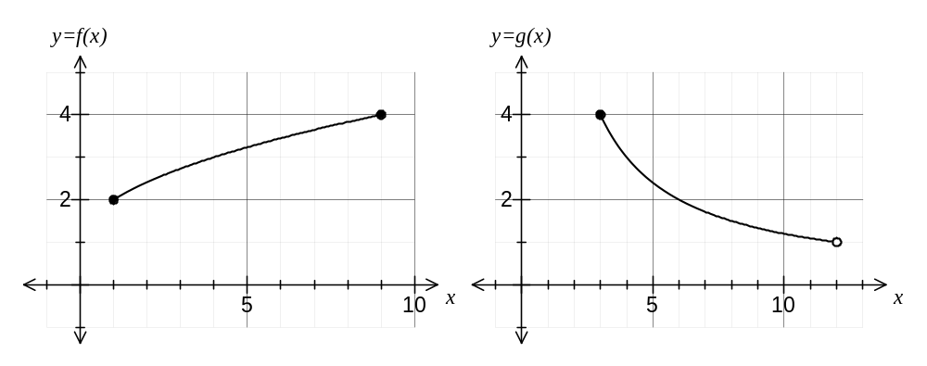
(a) Determine

(i) 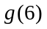 (1 mark)

(ii) 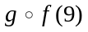 (1 mark)
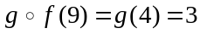

(b) Determine

(i) the range of 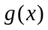 (1 mark)
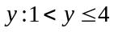

(ii) the range of 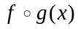 (2 marks)
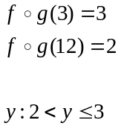

(iii) the domain of 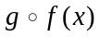 (2 marks)
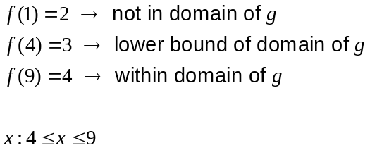

Question 16 (9 marks)
A rectangular sheet of paper with perimeter 84 cm is to be rolled into a cylinder. Let and be the dimensions of the sheet of paper, as shown below, and the radius of the rolled cylinder.

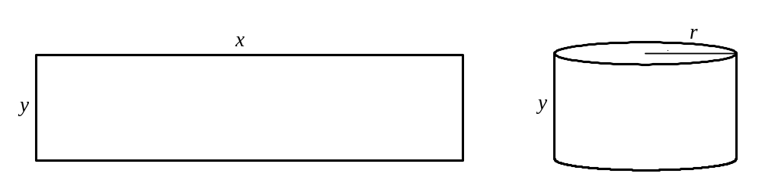

(a) Explain why 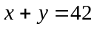. (1 mark)

By considering the perimeter:

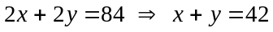

(b) Explain why 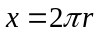. (1 mark)

The edge of the rectangle of length becomes the circumference of the circular end of the cylinder of radius

(c) Show that the volume of the rolled cylinder is given by 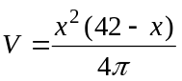. (3 marks)
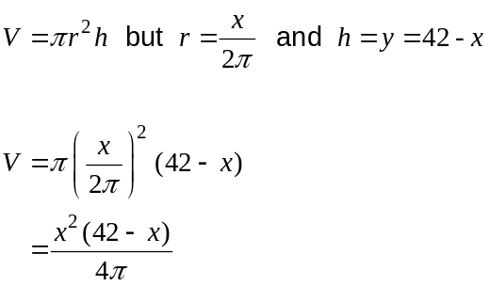

(d) Use calculus methods to determine the dimensions of the rectangle that maximise the volume of the cylinder and state this maximum volume. (4 marks)

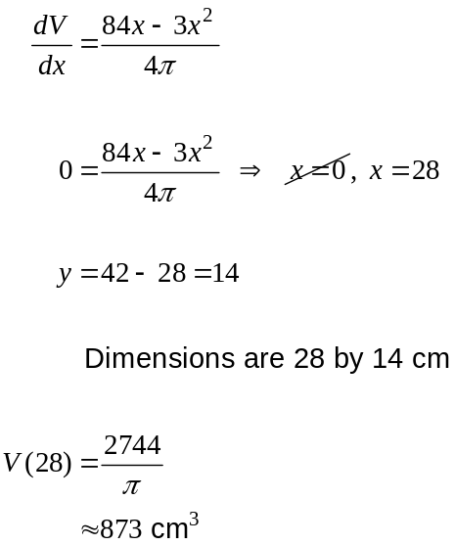

Question 17 (9 marks)
A bus service departs from a terminus every 30 minutes throughout the day. If a passenger arrives at the terminus at a random time to catch the bus, their waiting time, 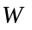in minutes, until the next bus departs is a uniformly distributed random variable.

(a) Sketch the graph of the density function of . (2 marks)
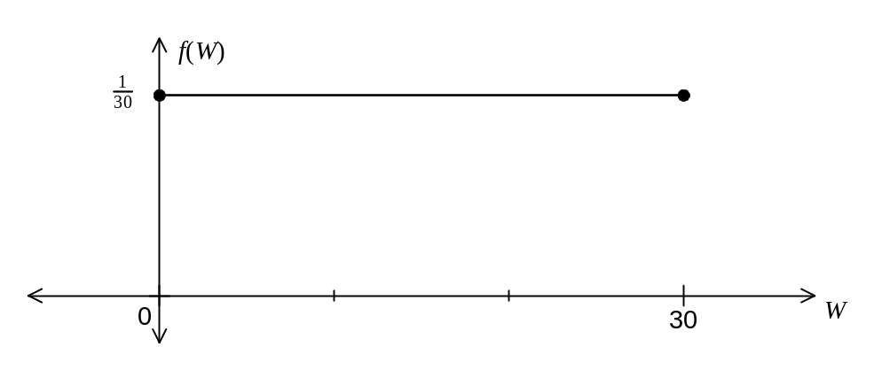

(b) What is the probability that a passenger who arrives at the terminus at a random time has to wait no more than 25 minutes for the bus to depart? (1 mark)
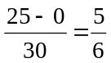

(c) What is the probability that fewer than four passengers, out of a random selection of ten, have to wait at least 25 minutes for the bus to depart?
(2 marks)
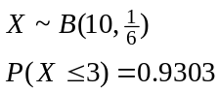

(d) Determine 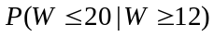. (2 marks)
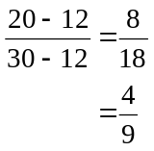

(e) Determine the value of for which 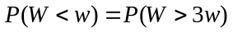. (2 marks)
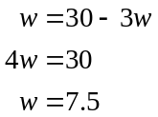

Question 18 (7 marks)
After a storm had passed, a yachtsman noticed that the labels had washed off 18 identical cans of food stored below deck. The yachtsman knows that six of the cans contain lamb stew and the remainder contain beef stew. The yachtsman selects four of the cans at random.

(a) What is the probability that all four cans selected contain beef stew? (2 marks)

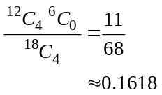

(b) What is the probability that no more than two cans selected contain lamb stew? (3 marks)

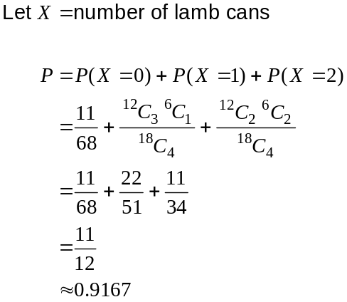

(c) The yachtsman opens two of the four cans selected and finds that they both contain beef stew. What is the probability that all four selected contain beef stew? (2 marks)

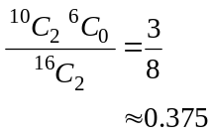

Question 19 (8 marks)
(a) Simplify

(i) 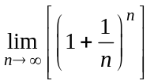 (1 mark)

(ii) 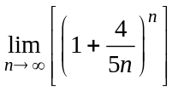 (1 mark)
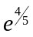

(b) Describe, in order, the transformations required to sketch the graph of 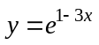 from the graph of 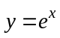. (3 marks)
1. Translate 1 unit left (parallel to -axis)

2. Reflect in -axis

3. Dilate parallel to -axis by scale factor

(NB Order of 2 & 3 can be swapped)

(c) The graph of 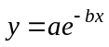 is shown below, where and are constants.
On the same axes, sketch the graph of 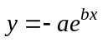. (3 marks)
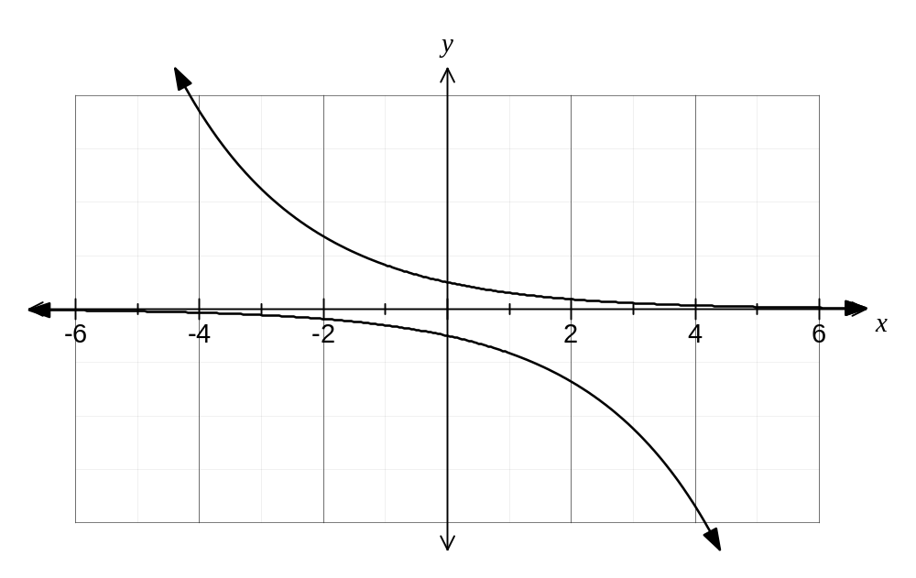

Additional working space

Question number: _________

Additional working space

Question number: _________

Additional working space

Question number: _________

This examination paper may be freely copied, or communicated on an intranet, for non-commercial purposes within educational institutes that have purchased the paper from WA Examination Papers provided that WA Examination Papers is acknowledged as the copyright owner. Teachers within Rossmoyne Senior High School may change the paper provided that WA Examination Paper's moral rights are not infringed.

Copying or communication for any other purposes can only be done within the terms of the Copyright Act or with prior written permission of WA Examination papers.

Published by WA Examination Papers
PO Box 445 Claremont WA 6910

